Link: <https://crackmes.one/crackme/5d443bb533c5d444ad3018b3>

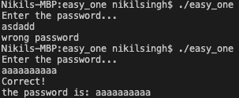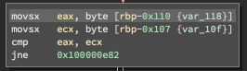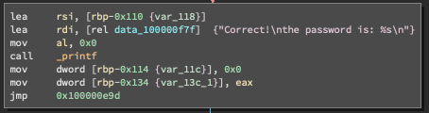Upon running the program, I discovered I needed to enter a password. Upon disassembling the code, I found the if statement that determined whether the password was correct. Tracing backwards from this I discovered a comparison and that the input string is held in ecx. Next I realised that it is comparing the same string with each other. At this point I became stuck, and got a hint from the solution. The program used fgets and relies on the user buffer overflowing. The overflow data would go into the variable password. Essentially, the program checks whether the first letter in input matches the first letter to enter the buffer overflow. If it passes that, then the password is correct.

